**LEBANESE AMERICAN UNIVERSITY**

**USAID – HIGHER EDUCATION SCHOLARSHIP PROGRAM**

**HES - Volunteering Program Verification Form**

This form is to be used to document volunteering hours. If a student volunteers for multiple organizations, a separate form must be used for each organization. **This form must be turned in by the 28th of each month, the latest.**

I certify that the scholar Lama Waked completed a total of 10 hours of service at InnovaThrive.

The hours were completed hours as per the below:

Hours # 0 (date) _2/12 – 6/12_ (initials of supervisor) __A.K.___

Hours # 0 (date) _9/12 – 13/12_ (initials of supervisor) __A.K.___

Hours # 0 date) _16/12 – 20/12 (initials of supervisor) __A.K.___

Hours # 10 date) _23/12 - 27/12 (initials of supervisor) __A.K.___

Brief description of the activities the scholar performed or participated in:

TASK #1  
  
AI in Mental Health Diagnostics Through Speech Patterns  
Definition: Using AI to analyze speech patterns for early signs of mental health disorders.  
Technologies:  
  
  
  
Speech recognition algorithms.  
  
  
  
  
NLP for detecting emotional tone and content in speech.  
  
Applications:  
  
  
  
  
Early detection of depression, anxiety, and bipolar disorder.  
  
  
  
  
AI-based virtual assistants for continuous mental health monitoring.  
  
Statistics:  
Studies show AI can identify depression with 85% accuracy from speech alone.  
  
Advantages:  
  
  
  
  
Accessible mental health support through AI-powered tools.  
  
  
  
  
Continuous monitoring for timely intervention.  
  
Disadvantages:  
  
  
  
  
Privacy concerns with sensitive data collection.  
  
Challenges:  
  
  
  
  
Ensuring accurate and culturally sensitive speech analysis.  
  
Future Research:  
  
  
  
  
Combining AI with wearable tech for real-time mood tracking.  
  
  
  
  
Enhancing diagnostic accuracy through multilingual AI models.  
  
  
TASK #2  
  
Blockchain for Transparency in Charitable Donations  
Definition: Using blockchain to ensure transparency and accountability in charitable donations.  
Technologies:  
  
  
  
Blockchain for tracking funds from donors to recipients.  
  
  
  
  
Smart contracts for automating fund distribution.  
  
Applications:  
  
  
  
  
Real-time tracking of charity funds.  
  
  
  
  
Preventing mismanagement and ensuring funds reach intended causes.  
  
Statistics:  
Blockchain platforms report a 40% increase in donor trust.  
  
Advantages:  
  
  
  
  
Enhanced transparency and accountability in charitable donations.  
  
Disadvantages:  
  
  
  
  
Difficulty in achieving global adoption for small NGOs.  
  
Challenges:  
  
  
  
  
Overcoming resistance from traditional charity models.  
  
Future Research:  
  
  
  
  
Integrating blockchain with AI to assess the impact of donations.  
  
  
Expanding blockchain for global micro-philanthropy.

Written feedback about the scholar’s performance:

Lama exhibits excellent research skills in tackling AI applications in mental health diagnostics and blockchain for charity transparency. Her thorough analysis, attention to privacy concerns, and ability to identify challenges and solutions demonstrate exceptional problem-solving and analytical abilities.

Please rate the overall performance of the scholar at your organization:

|  |  |  |  |
| --- | --- | --- | --- |
|  | Mastery (5) | Proficient (3) | Emerging (1) |
| **Problem solver** | X |  |  |
| **Engaged & Committed** | X |  |  |
| **Open-minded & multicultural** | X |  |  |

Signature

& stamp

__________________________

_

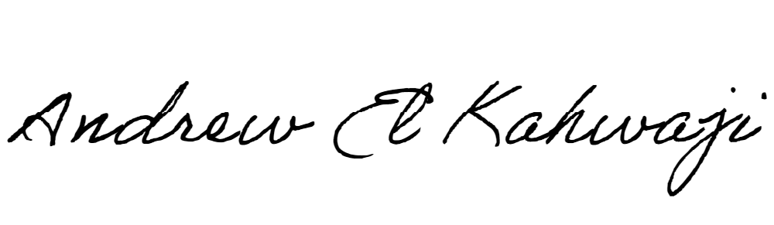

Printed Name _Andrew El Kahwaji_

Date __26/12/2024___

Email __andrew.lifesculptor.coo@gmail.com __

Phone __+961 71 914 378__